Virtusa React Training

B Sahil (221910304005)

Day 4

**State:**

A state is a data container same as variable, whenever the value of the state is changed immediate effect will be there.

**Syntax:**

**const(data, set data) = use data(“abc”);**

Data -> name of the variable

setData-> updating to the new value

useData -> to initialize starting value of the variable

State can be used in **both** functional component and class component.

In class component, if you want to use state concept, we need to have a constructor and, in that constructor, we need to call super constructor and we need to access the variables with the help of ‘this’ keyword.

Declaration of a variable with related to state, in class component can be written as

**this.data={**

**data=1;**

**}**

‘this’ can be also declared as **this.state={ data=1;}**

**setState** is used to update the value of the present variable.

1. Program to demonstrate the concept of variable without using state.

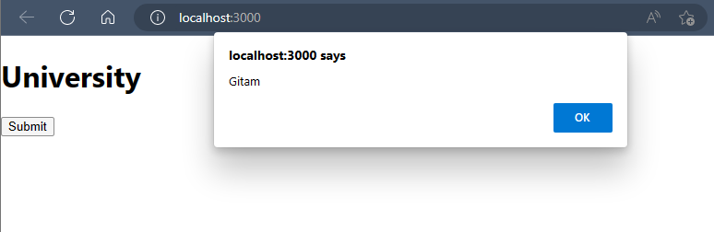

App.js

import React from 'react'

export default function App() {

  function Apple(){

    var item="Gitam";

    alert(item);

  }

  let item="University";

  return(

    <div>

      <h1>{item}</h1>

      <button onClick={Apple}>Submit </button>

    </div>

  )

}

1. Program to demonstrate the concept of state by using functional component.

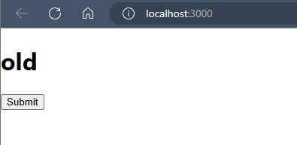

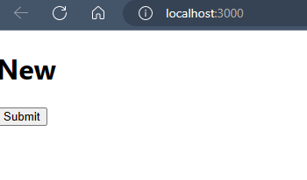

App.js

import React from 'react'

import { useState } from 'react';

export default function App() {

  const [item, setitem] = useState("old")

  function Update(){

    setitem("New");

  }

  return (

    <div>

      <h1>{item} </h1>

      <button onClick={Update}> Submit</button>

    </div>

  )

}

1. Program to demonstrate the concept of state by using Class component.

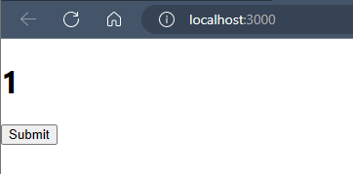

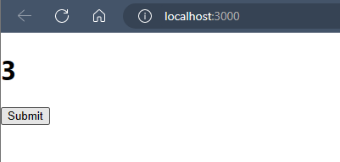

import React, { Component } from 'react'

export default class App extends Component {

  constructor(){

    super();

    this.state={

      data:1

    }

  }

  update() {

    this.setState({data:this.state.data+1})

  }

  render() {

    return (

      <div>

        <h1>{this.state.data}</h1>

      <button onClick={()=>this.update()}>Submit</button>

      </div>

    )

  }

}